H.T No
Regulations:
A18

Sreenidhi Institute of Science and Technology
(An Autonomous Institution)
Code No: 7AC07 Date: 30-Sept-2021(AN)

B.Tech II-Year II- Semester External Examination, Sept/Oct-2021 (Supplementary)
CONTROL SYSTEMS (EEE)

Time: 3 Hours Max.Marks:70

Note: a) No additional answer sheets will be provided.
b) All sub-parts of a question must be answered at one place only, otherwise it will not be valued.
c) Missing data can be assumed suitably.

ANSWER ANY 5 OUT OF 8 QUESTIONS. EACH QUESTION CARRIES 14 MARKS.

Bloom's Cognitive Levels of Learning (BCLL)

Remember | L1 | Apply | L3 | Evaluate | L5
Understand | L2 | Analyze | L4 | Create | L6

 |  |  | BCLL | CO(s) | Marks
1. |  | Find transfer function C(s)/R(s) of the block diagram shown below using signal flow graph method.  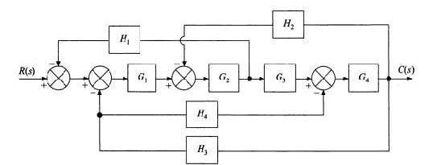  H1  H2  H1  H2  G1  G2  G1  G3  G4  H4  H3  C(s)  R(s) | L5 | CO1 | [14M]
2. | a) | The unity feedback control system is characterized by an open loop transfer function 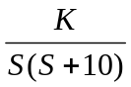 Determine gain K, so that the system will have damping ratio of 0.5. Determine peak overshoot and peak time for a unit step input. | L4 | CO2 | [7M]
 | b) | Explain steady state error for various types of inputs. Find the steady state error with unity feedback system given by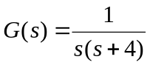 for the input 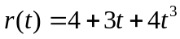. | L3 | CO2 | [7M]
3. |  | Sketch the root locus of the open loop transfer function given below. 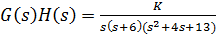 | L4 | CO3 | [14M]
4. |  | Sketch the Bode plot for the following transfer function and determine the system gain K for the gain cross over frequency to be  i) 10 rad/s ii) 0.5 rad/sec 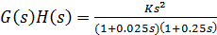 | L4 | CO4 | [14M]
5. | a) | Write the procedure for the design of a lag compensator. | L1 | CO5 | [7M]
 | b) | What are the effects of phase lead compensation? | L1 | CO5 | [7M]
6. |  | Obtain state model of the system given by transfer function  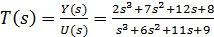 | L4 | CO6 | [14M]
7. | a) | What is minimum phase system? | L2 | CO1 | [5M]
 | b) | Distinguish between absolute stability and relative stability. | L3 | CO2 | [5M]
 | c) | What are the advantages and drawbacks of Routh stability criterion? | L2 | CO3 | [4M]
8. |  | Test the controllability and observability of the system described by  = 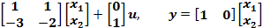 | L4 | CO6 | [14M]
-- 00 -- 00 –

